

InstallShield®

Tuner OEM 3.5

Setup

Specification

Owner(s) Jigar Desai

Last Updated 9/30/2004 03:16:00 PM

File Name 0000.doc

© 1999 InstallShield Software Corporation. All rights reserved.
THIS IS PRELIMINARY DOCUMENTATION. The information contained in this document represents the current view of InstallShield Software Corporation on the issues discussed as of the date of publication. Because InstallShield must respond to changing market conditions, it should not be interpreted to be a commitment on the part of InstallShield, and InstallShield cannot guarantee the accuracy of any information presented after the date of publication.
This BETA document is for informational purposes only. INSTALLSHIELD MAKES NO WARRANTIES, EXPRESS OR IMPLIED, IN THIS DOCUMENT.
Other product or company names mentioned herein may be the trademarks of their respective owners.
InstallShield Software Corporation • 900 National Parkway • Schaumburg, Illinois 60173-5108

Table of Contents

^{1.0 Abstract} 3
^{2.0 Requirements} 3
3.0 Features Reserved for Future Versions 4
^{4.0 Limitations} 4
^{5.0 Issues} 4
^{6.0 Revision History} 4

^{1.0 Abstract}
This documents outlines the requirements for the InstallShield Tuner OEM 6.0 setup.

^{2.0 Requirements}

- Perform an upgrade from previous versions of Tuner.
- Have a new product code and package code.
- Validate the serial number in the UISequence and ExecuteSequences.
- Launch the registration wizard at the end of the install.
- Setup will consists of the following:
    - 1 feature with 2 sub features. The top level feature will include files require for Full and eval editions.
    - A merge module - InstallShield_Tuner.msm with all the tuner files.

- All features will be installed on the local machine.
- INSTALLDIR will be installed in <ProgramFiles>\InstallShield\Tuner

Typical Shortcuts are shown here.

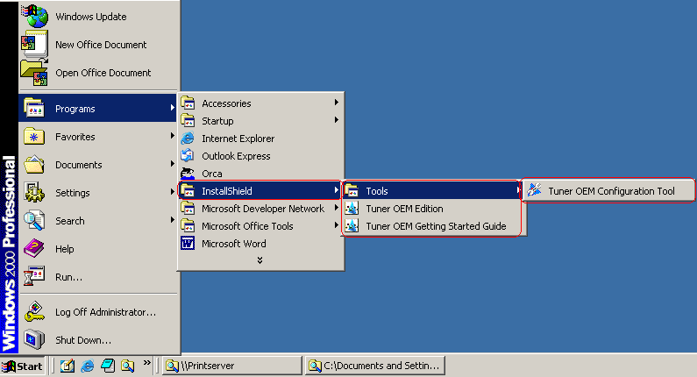

- Launch the registration wizard at the end of the install.

3.0 Features Reserved for Future Versions

^{4.0 Limitations}

^{5.0 Issues}

^{6.0 Revision History}

Date | Author | Change Reference
08/22/2004 | Jigar Desai | Initial Draft

